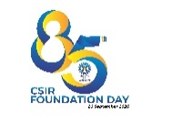
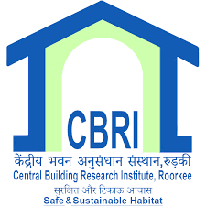
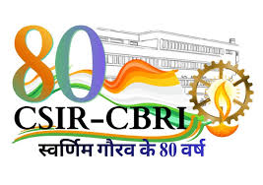
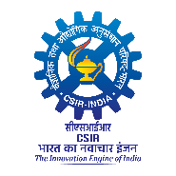

Outreach & Dissemination Services Office

CSIR – Central Building Research Institute Roorkee 247667 (UK)
Exhibition
August 21-23, 2026

ACHIEVE-2026 – International Conference-cum-Expo
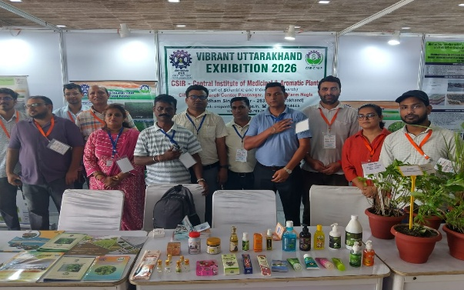
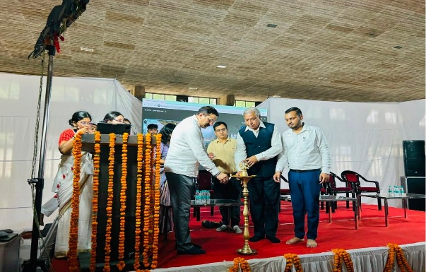
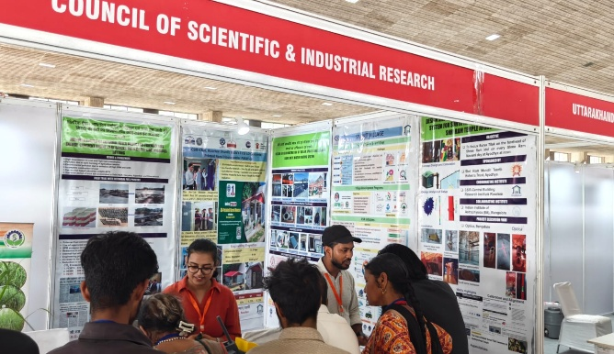
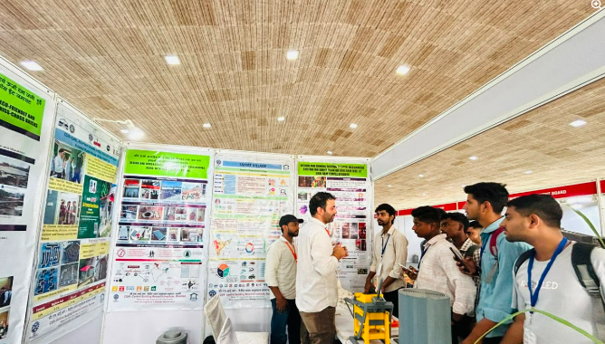
CSIR–Central Building Research Institute (CSIR-CBRI), Roorkee participated in ACHIEVE-2026 – International Conference-cum-Expo, organised at Prem Nagar Ashram, Haridwar, as part of the Himalayan MSME Expo, India Export Expo and Asia Agri, Horti & Organic Expo, from 21–23 August 2026. The event brought together entrepreneurs, MSMEs, industry professionals, researchers and other stakeholders, providing a platform for technology dissemination, knowledge exchange, industry–research interaction and exploring potential collaborations. CSIR-CBRI participated in the event by showcasing its indigenous research, technologies and innovations in the areas of building science, sustainable construction, advanced construction technologies and resilient infrastructure. The event was formally inaugurated by Prof. Rajesh Kumar Dubey, Professor & Director, UGC-MMTTC, JNV University, Jodhpur, in the presence of Mr. S.P. Rathore, Founder & CEO, EFAS, organiser of the event, and Ms. Manisha Jha, Guest Speaker. Following the inauguration, the distinguished guests visited the CSIR-CBRI exhibition stall and interacted with the CBRI team. They took keen interest in the technologies and research initiatives showcased by the Institute and appreciated the efforts of CSIR-CBRI in translating scientific research into practical, indigenous and technology-driven solutions for the nation’s built environment. The exhibition stall showcased a range of CSIR-CBRI technologies and innovations, including the Ram Mandir Foundation technology, developed for addressing foundation-related challenges; Surya Tilak technology, demonstrating an innovative application of solar illumination; and 3D-printed construction technology, highlighting the potential of additive manufacturing for sustainable and rapid construction. The Smart Village Initiative was also showcased, presenting an integrated approach towards improving rural infrastructure and promoting appropriate technologies for rural development. Technologies related to energy-efficient brick kiln systems were displayed to highlight solutions for improving the efficiency and environmental performance of brick production. The Bud Block Machine was also showcased as an indigenous technology aimed at supporting sustainable and resource-efficient construction practices. These technologies demonstrated the Institute’s efforts towards developing cost-effective, sustainable, locally appropriate and scalable solutions for the construction and infrastructure sectors.

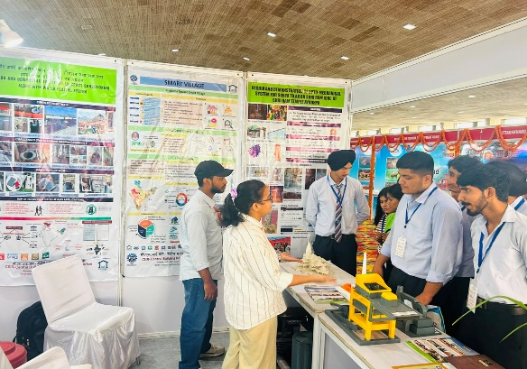
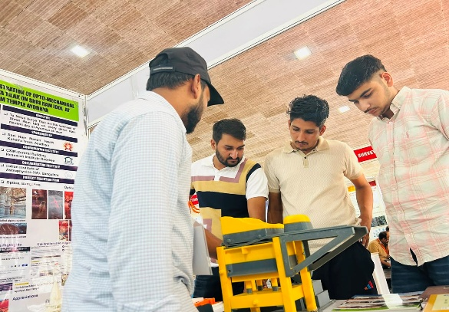
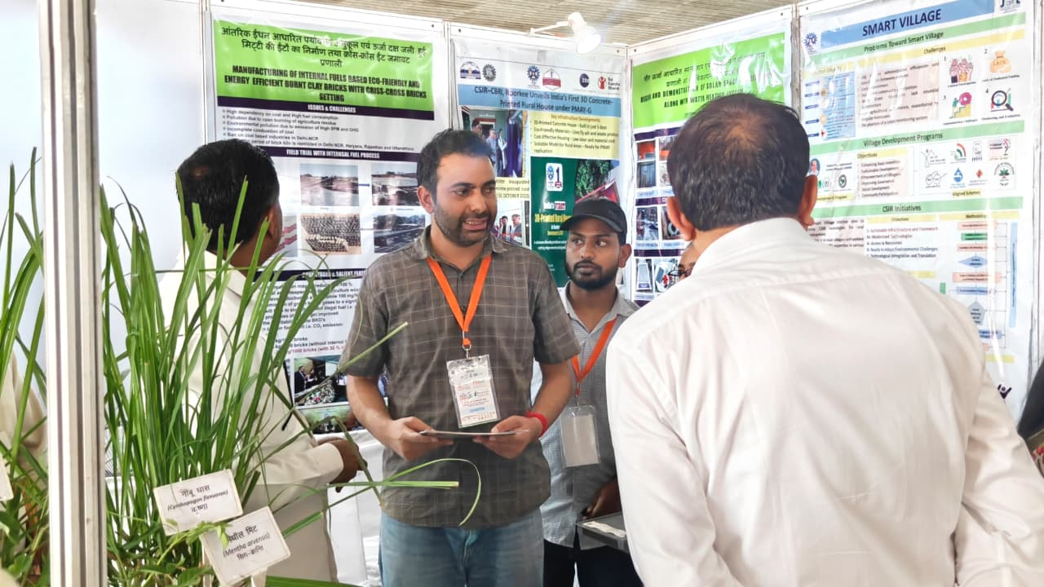
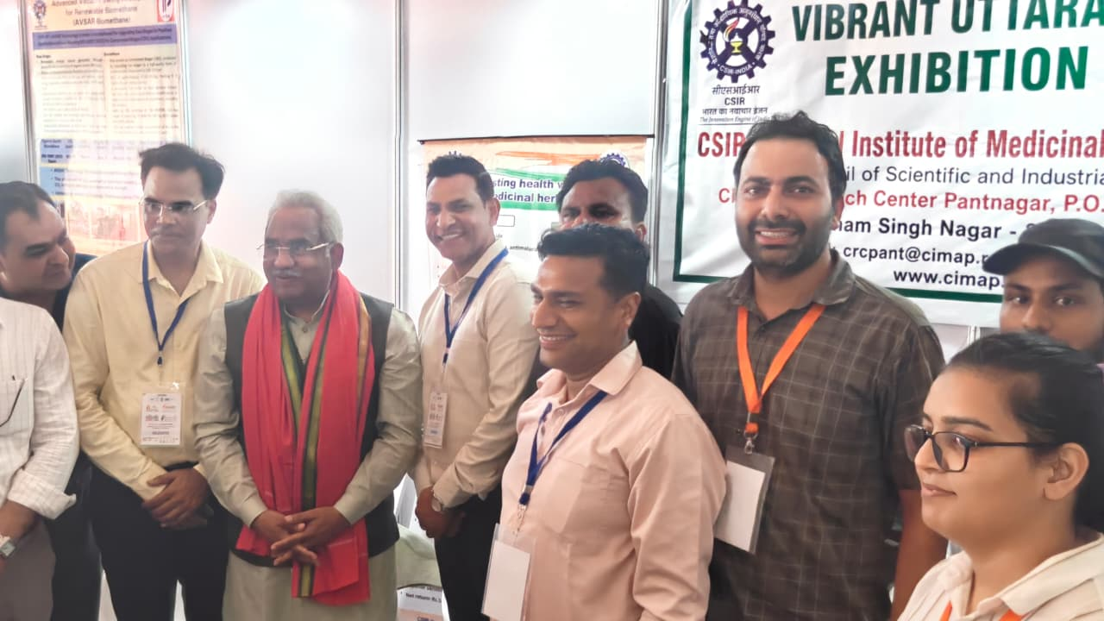
During Day 2, the CSIR-CBRI exhibition stall was visited by distinguished dignitaries, including Mr. Adesh Chauhan, MLA, Ranipur, and Shri Madan Kaushik, Cabinet Minister. The dignitaries interacted with the CBRI team and took keen interest in the Institute’s research, technologies and innovations in building science, sustainable construction and resilient infrastructure. They appreciated the Institute’s contributions towards developing and disseminating innovative, indigenous and technology-driven solutions for the nation’s built environment.

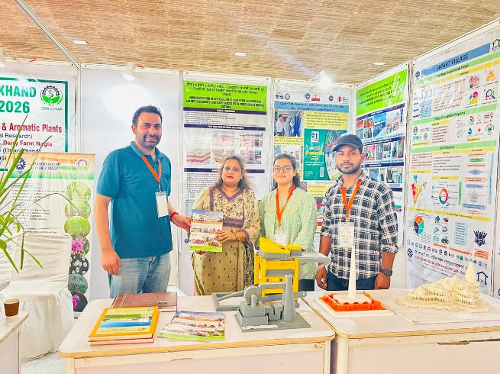
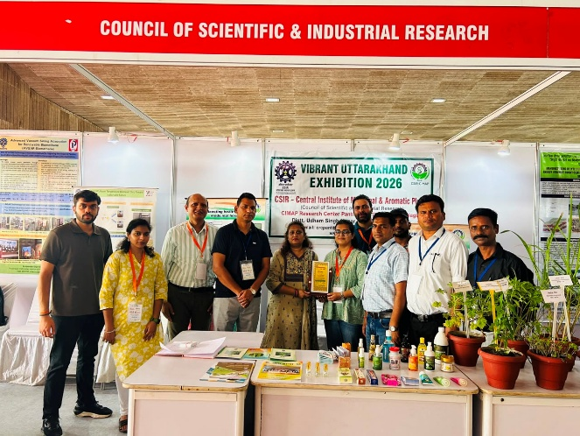
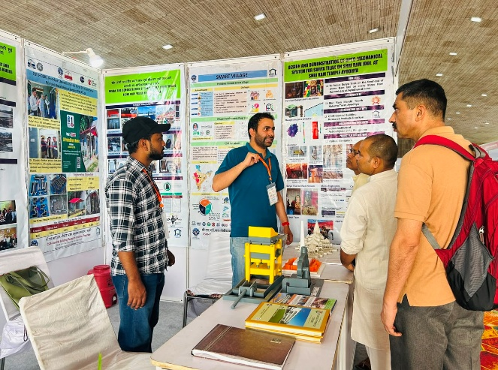
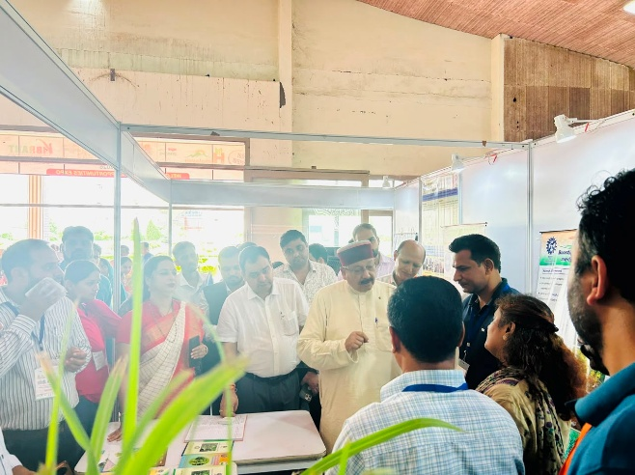
On Day 3, the exhibition stall was visited by Shri Satpal Ji Maharaj, Tourism Minister, Government of Uttarakhand. He interacted with the CBRI team and took keen interest in the technologies and research initiatives showcased by the Institute. Shri Satpal Ji Maharaj appreciated the efforts of CSIR-CBRI towards developing and disseminating innovative, indigenous and technology-driven solutions for the nation’s built environment. The participation of CSIR-CBRI in ACHIEVE-2026 provided an important platform for technology demonstration, stakeholder engagement, industry–research interaction and knowledge exchange. The exhibition enabled the Institute to disseminate information about its technologies among MSMEs, entrepreneurs, industry representatives, professionals and other stakeholders, while creating opportunities for potential technology adoption and collaborations. The participation also highlighted CSIR-CBRI’s efforts towards taking research and innovation from the laboratory to real-world applications and promoting sustainable and resilient construction practices. Prof. R. Pradeep Kumar, Director, CSIR-CBRI, extended his best wishes and appreciation to the team for representing the Institute and showcasing its innovative technologies and research contributions at the event. Through its participation in ACHIEVE-2026, CSIR-CBRI reaffirmed its commitment to technology dissemination, sustainable construction, rural development, energy efficiency and resilient infrastructure, contributing towards the vision of a sustainable, technology-driven and self-reliant India.

